**How Do Two Neighboring Countries in East Asia Hold Varying Perspectives on President Trump's Election and Mutual Tariff Imposition?**

Jaehyun Kim, Tongtong Li, Fengqi Liu, Sohyeon Ryu

# Motivation

On November 6, 2024, Donald Trump was elected as the 47th President of the United States. After serving as the 45th President, he returned to the White House after just two election cycles. Furthermore, on April 3, 2025, Trump announced substantial mutual tariffs targeting 183 countries, sending shockwaves through international trade. This report examines the varying reactions of different foreign nations to these two significant events: Trump's election and his tariff announcement.

Nations inevitably perceive and interpret these events differently based on their existing political and economic relationships with the United States and their perceptions of Trump as a political figure. This report analyses how different conditions in neighboring countries—South Korea and China—lead to divergent reactions to the same events through sentiment analysis. We compare user comments on the most actively used video platforms in each country (YouTube in South Korea and Bilibili in China) to conduct a comparative sentiment analysis. The following section provides background on each country's relationship with the United States and their video platform usage patterns, followed by our methodology and conclusions.

# Background

The United States and China are the world’s two largest economies, closely linked through cooperation yet frequently positioned as strategic rivals. Political shifts and policy changes in either country can have far-reaching consequences—not only for each other but also for the global landscape. South Korea, as a close ally of the United States, is particularly sensitive to U.S. policy changes, which can significantly impact its economy. This study is driven by a strong interest in understanding how ordinary people in both China and South Korea respond to major international events, offering insight into their perspectives and emotional reactions.

During Trump’s first term in office (2017-2021), President Donald Trump adopted a confrontational and transactional approach toward China, marking a sharp departure from previous U.S. administrations. His policies centered on reducing the U.S. trade deficit and countering what he viewed as unfair trade practices, leading to a prolonged and high-stakes trade war. Key measures included imposing tariffs on hundreds of billions of dollars’ worth of Chinese goods, restricting Chinese investment in U.S. technology sectors and confronting intellectual property loss. Trump also emphasized decoupling critical supply chains and signed the “Phase One” trade deal in 2020, aiming pressure China into purchasing more American products and reforming its economic practices. His administration’s tone was often nationalistic and adversarial, framing China as a strategic competitor not only in trade but also in geopolitics, technology, and military affairs. They are regarded as an unstable politic factor for the world.

In 2025, President Donald Trump intensified his tariff policies toward China, escalating trade tensions between the tow nations. Invoking a national emergency, he imposed a 10% tariff on all Chinese impots, citing concerns over China’s role in the U.S. opioid crisis. Subsequent increases raised tariffs to 20% in March and further to 54% in April, culminating in a peak rate of 145% by mid-April. China retaliated with its own tariffs, reaching up to 125% on American goods, and implemented export controls on critical materials like rare earth elements. These measures disrupted global supply chains and strained economic relations. However, by May, both countries engaged in high-level trade talks in Geneva, signalling a potential de-escalation. President Trump described the discussions as a “total reset”, with indications of reducing tariffs to around 80%, aiming to stabilize bilateral trade relations.

South Korea and the United States maintain highly amicable political relations. Their historical alliance developed after Korea's independence from Japan, with the United States involved in establishing the South Korean government and participating in the Korean War. This friendly relationship is evidenced in multiple ways: approximately 28,000 U.S. military personnel are stationed throughout South Korea, including in central Seoul, and South Korea ranks third—after India and China—in sending international students to the United States. Economically, the relationship is equally close. The United States ranks as South Korea's second-largest trading partner, while South Korea is the United States' sixth-largest trading partner. Since 2012, a free trade agreement between the two countries has facilitated increased economic exchange.

South Korea's political and economic characteristics, combined with experiences during Trump's first term, have likely generated specific perceptions and sentiments among South Koreans regarding Trump as U.S. President. During Trump's first administration, U.S.-South Korea relations were marked by bold North Korea policies, calls for U.S. troop withdrawal from South Korea, and demands for a five-fold increase in South Korea's costs for hosting American troops. While most of these did not realize, South Koreans experienced political, military, and security pressure from the United States during this period. Relatively speaking, economic pressure was less significant. When the U.S.-China trade war erupted in 2018, the United States requested FTA revisions from South Korea, which South Korea accommodated through minor concessions and adjustments in sectors such as automobiles. Consequently, South Korea did not experience trade disruptions as severe as China did.

These perceptions and sentiments are widely reflected in comments on YouTube, the most extensively used video platform across all generations and regions in South Korea. Remarkably, YouTube usage rates are also very high among middle-aged and older adults over 50. Official accounts of Korean public broadcasting networks such as KBS (Korea Broadcasting System), MBC, and SBS upload official news clip videos, including breaking news, to their YouTube channels. According to Na et al. (2025), impolite language accounts for 23.9% and hate speech for 7.5% of YouTube comments on political news videos. Empirically, comments on Korean news YouTube videos tend to be sharply divided along political lines, with emotional expressions and criticism frequently appearing. This demonstrates not only the high level of interest among ordinary citizens in political issues but also the extreme conflicts that can arise.

# Methods

This study employs a combination of word frequency analysis (word clouds) and sentiment score analysis to explore public reactions to Donald Trump's re-election and the subsequent mutual tariff announcement. Word clouds are used to identify the most frequently mentioned terms, while sentiment scoring quantifies the emotional tone—positive, negative, or neutral—over time. We use different methods to analyse the comments in Chinese and Korean version. For China part, we employ the bilibili-comment-crawler which is a Python-based tool designed to extract comments from Bilibili videos. By inputting a video's BV number, the script retrieves both primary comments and nested replies, capturing user details such as ID, nickname, level, gender, IP location, and membership status. It handles pagination automatically and employs techniques like timestamping and MD5 encryption to mitigate anti-scraping measures. The collected data is exported to CSV files, facilitating further analysis or visualization. Users must provide their Bilibili cookies and User-Agent information to authenticate requests, ensuring access to complete comment data.

Then, we leverage the bixin project which is also a Python-based tool for Chinese sentiment analysis. It utilizes a dictionary and rule-based approach. The sentiment scores range from -1 to 1 to input text, indicating negative to positive sentiments, respectively. The tool employs jieba_fast for word segmentation, enhancing compatibility and ease of installation compared to its predecessor, cppjieba-py. With an accuracy of approximately 82.8% on a diverse corpus—including shopping reviews, Sina Weibo posts, hotel reviews, and financial news—bixin offers a straightforward API for sentiment prediction. This makes it particularly suitable for lightweight applications and batch processing tasks in Chinese text analysis.

For South Korea part, sentiment analysis was conducted using a VADER-style scoring approach based on “KoELECTRA,” a Korean-specific transformer model optimized for short, informal, social media-style texts such as YouTube comments. Rather than assigning a single categorical label, the model produces a probability distribution across multiple predefined emotional categories (e.g., “annoyed,” “sad,” “happy”). Each category was mapped to a sentiment polarity score ranging from –1 (strongly negative) to +1 (strongly positive), and the final sentiment score was calculated as a probability-weighted average. This VADER-style method captures both the direction and intensity of emotional responses, enabling a more nuanced understanding of public opinion

To examine shifts in public sentiment across the two events, we applied K-means clustering to the sentiment score distributions using principal component analysis (PCA) for dimensionality reduction. Although PCA-based clustering can result in information loss and reduced interpretability, especially when collapsing complex linguistic data into just a few components, it was still deemed appropriate for this study. This approach allowed us to uncover broad emotional divides and detect whether qualitatively different clusters of discourse emerged in response to each event, particularly in reaction to the unexpected tariff announcement, which triggered stronger and more varied emotional responses than the election itself.

In PCA, each word in the corpus is projected onto new axes (principal components) that capture the largest variance in the data. The weights (or loadings) represent how strongly each word contributes to each principal component. By analysing these loadings, we identified which words had the greatest influence on shaping each principal component and, by extension, the underlying emotional and thematic dimensions of the data. After identifying these influential terms, we further examined the TF-IDF scores of words within each cluster to explore what specific topics were being discussed. This two-step approach—first identifying the general emotional axes through PCA, then uncovering topic-specific content through TF-IDF—allowed us to interpret both the overall structure and the distinct topic of each cluster more clearly.

# Results with Chinese Videos

## Selected Chinese videos

We collected user comments from the five most-commented videos on Bilibili (often referred to as “China’s YouTube”) discussing Donald Trump’s victory in the 2024 U.S. presidential election. The keyword for video search is “特朗普胜选” (“Trump won the election”). We also collected the five most-viewed videos about Trump’s tariff policies in 2025. The keyword for those videos are “特朗普关税”(Trump’s Tarrif).

These five videos of Trump’s presidential election include one published by CCTV News, China’s official state media outlet, while the remaining four were uploaded by individual content creators. Another five videos of Trump’s tariff policies are all released by individual content creators. We conducted both word frequency analysis and sentiment analysis on these comments.

Table 1. Five most commented video of Trump’s election

|  |  |  |  |  |
| --- | --- | --- | --- | --- |
| **Video Name (Chinese)** | **Video Name (English)** | **Date** | **Channel** | **# of Comments** |
| 特朗普宣布胜选 | Trump Claims Election Victory | 11/06/2024 | CCTV NEWS  (央视新闻) | 15154 |
| 败选后再胜选，这复仇的滋味多美妙谁能比他更懂 | Losing Then Winning Again — Who Knows the Sweet Taste of Revenge Better Than Him? | 11/07/2024 | 麻薯波比呀 | 4265 |
| 特朗普胜选后，拜登笑得比花灿烂，嘴角比AK还难压 | After Trump’s Victory, Biden’s Smile Blooms Brighter Than Flowers | 11/08/2024 | 江平舟 | 4955 |
| 【深度】特朗普胜选！美国公务员清除计划启动！ | [In-Depth] Trump’s Victory: U.S. Civil Servant Purge Plan Begins! | 11/03/2024 | CLS同学 | 2487 |
| 川普以277票大胜哈里斯后，对国际和国内有哪些影响？ | After Trump’s 277-Vote Landslide Over Harris, What Are the Impacts Domestically and Internationally? | 11/06/2024 | 卢克文工作室 | 2564 |

Table 2. Five most viewed videos of Trump’s tariff policies

|  |  |  |  |  |
| --- | --- | --- | --- | --- |
| **Video Name (Chinese)** | **Video Name (English)** | **Date** | **Channel** | **# of Comments** |
| 特朗普关税王八拳，打中国，打美元， 国际贸易必然重塑 | Trump’s Tariff King Punches: Hitting China, the U.S. Dollar, and America — A Reshaping of Global Trade Is Inevitable | 04/10/2025 | 小王Albert | 9671 |
| 【爆笑每日秀】美国人吐槽特朗普加征关税，全程高能讽刺 | [Hilarious Daily Show] Americans Roast Trump for Raising Tariffs — Packed with High-Energy Sarcasm | 04/06/2025 | 米国脱口秀 | 5399 |
| 特朗普实施对等关税，赌你们的枪里没有子弹？ | Trump Implements Reciprocal Tariffs — Do You Even Have Bullets in Your Guns? | 04/05/2025 | 麻薯波比呀 | 11665 |
| 【巫师】全球关税混战背后，是不能输的终局之战 | [Wu Shi] Behind the Global Tariff Chaos Lies the Final Battle That Must Not Be Lost | 04/08/2025 | 巫师财经 | 14042 |
| 【厉害】海湖庄园协议：特朗普疯狂关税背后，最终棋局是什么？ | [Li Hai] Mar-a-Lago Agreement: What Is the Endgame Behind Trump’s Tariff Frenzy? | 04/12/2025 | 厉害财经 | 1685 |

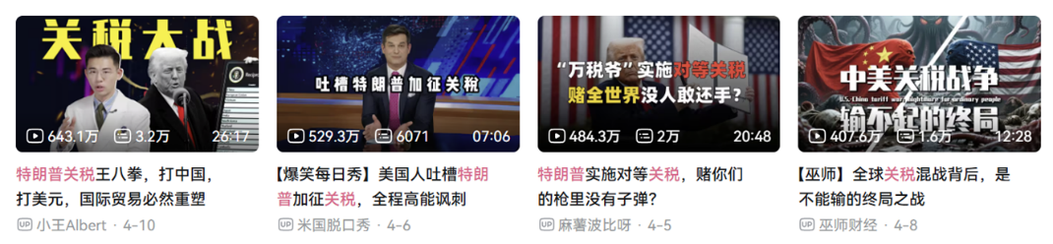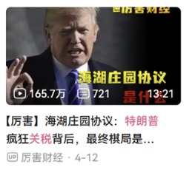

## Temporal distribution of comments

We consolidated the comments from all the videos into a single dataframe and plotted the daily comment volume, as shown in the figure below. The majority of comments were posted during the election week (2024-11-05 ~ 2024-11-11) and the reciprocal tariff announcement (2025-04-05 ~ 2024-04-11).

Figure 1. Daily number of comments

## Top 5 most liked comments in “election” videos

Among the five most-liked comments：

* the first one mocked Kamala Harris for losing the election;
* the second reflected on Elon Musk’s critical role in facilitating Trump’s victory;
* the third conveyed a conspiratorial tone, speculating that Biden, as a shrewd political strategist, might have secretly assisted Trump;
* the fourth expressed amazement that Trump survived an assassination attempt and also conveyed hope for China’s continued prosperity;
* the fifth praised Trump’s sweeping success in securing seven swing states.

Table 3. Top 5 most liked comments in “election” videos

|  |  |  |  |
| --- | --- | --- | --- |
| Username | Comment Text | Like Count | Comment Time |
| 写张卷子冷静下- | 假如你是李华，你的朋友哈里斯告诉你，她输掉了大选，心情非常沮丧，你要写一封信安慰一下她。要求在120词左右。 | 36106 | 2024-11-06 15:37:37 |
| 雨未歇べ | 埃隆马斯克这种金牌辅助，收购推特真是神助攻，确实厉害，首富的眼光和胆识 | 24400 | 2024-11-06 11:04:06 |
| 打不过就喷口水 | 可能很多人忘记了，拜登虽然是个老人，但他是冷战思维的政治家，谁得罪他，他自然而然就会站在得罪他的人的对立面 | 19471 | 2024-11-08 15:07:40 |
| -_-狐尼克-_- | 那颗子弹偏移了1㎜。命运的齿轮改变了，不知道历史会怎样谱写。只希望中华人民共和国 繁荣富强 国泰民安。普通老百姓以后的生活好一点。 | 13504 | 2024-11-06 11:42:24 |
| 奶油浓汤ww | 摇摆州7:0，这是致敬啊 | 12773 | 2024-11-07 03:14:26 |

## Top 5 most liked comments in “tariff shock” videos

Among the five most-liked comments：

* the first comment laments the massive losses in the user’s stock account;
* the second comment questions why Trump supporters fail to realize that they are the ones who have to bear the cost of tariffs;
* the third comment mocks Trump’s failed casino ventures;
* the fourth comment ridicules Trump for imposing tariffs on an island inhabited only by penguins.

Table 4. Top 5 most liked comments in “tariff shocks” videos

|  |  |  |  |
| --- | --- | --- | --- |
| Username | Comment Text | Like Count | Comment Time |
| 四月阿- | 今天自己洗车省了40块钱，下午打开股票账户一看车没了 | 36335 | 2025-04-07 11:17:19 |
| 大地怒吼2 | 很多MAGA是真的不知道关税最终是由自己承担的 | 15922 | 2025-04-05 11:12:27 |
| 282364786 | 特朗普赌场都能经营倒闭 到这真绷不住了 | 13459 | 2025-04-06 10:45:20 |
| 深圳全球速递 | 在川普的关税中有个叫做赫德岛和麦克唐纳群岛的国家，川普对他收取了10%的关税 但是该岛是个无人居住的小岛，岛上只有企鹅🐧 | 9987 | 2025-04-07 08:32:06 |
| 39_Z01 | 顶级回旋镖 | 8843 | 2025-04-07 12:54:19 |

## Word Cloud

Before generating the word cloud, we removed keywords that were bound to appear, such as Trump, Musk, Harris, Biden, the Democratic Party, the Republican Party, trade war, and tariffs. Among the five videos related to the election, frequently occurring words included “history”, “return”, “hope”, and “wages” (see Figure 2). This suggests that commenters may have felt they were witnessing a historic moment, were surprised by Trump’s return after four years, and were concerned about how their wages might be affected.

In the five videos related to the reciprocal tariffs, the most frequently mentioned words were “U.S. dollar”, “economy”, “cost”, “manufacturing”, and “war” (see Figure 3). This suggests that commenters were deeply concerned about the costs of the tariff war and were keen to discuss its implications for the status of the U.S. dollar and the global manufacturing landscape.

Figure 2. The word cloud of comments in election videos

Figure 3. The word cloud of comments in tariff shock videos

## Sentiment analysis

The sentiment scores of video comments were highly polarized in both periods: there were a large number of both very negative and very positive comments, roughly equal in volume. Of course, many comments were also emotionally neutral. In addition, following the tariff shock, the proportion of negative comments increased.

Figure 4. Distribution of sentiment scores (normalized)

After the tariff shock, compared to the period following the election, the sentiment of comments mentioning Trump shifted from positive to negative. Comments referencing “trade” and “tariffs” became more negative in sentiment, while those mentioning “South Korea” became more positive—perhaps because both China and South Korea were subject to the new tariffs.

Table 5 Sentiment scores of comments with specific keywords

|  |  |  |  |
| --- | --- | --- | --- |
|  | “Trump” | “Trade” or “Tariff” | “South Korea” |
| After the election | 0.0871 | -0.0512 | 0.0227 |
| After the tariff shock | -0.0765 | -0.0882 | 0.2567 |

In addition, the number of comments from female users was significantly lower than that from male users. Female commenters also expressed more negative sentiments. After the tariff shock, the sentiment of commenters across all genders became more negative.

Table 6 Comment counts and sentiment scores by gender

|  |  |  |  |  |
| --- | --- | --- | --- | --- |
|  | After the election | | After the tariff shock | |
|  | Comment count | Average sentiment | Comment count | Average sentiment |
| Female | 611 | -0.0041 | 865 | -0.0335 |
| Male | 4250 | 0.0286 | 4547 | -0.0440 |
| Secret | 7514 | 0.0201 | 8967 | -0.414 |

## Sentiment scores by provinces

Since Bilibili also records the commenter’s province based on their IP address, we are able to examine the sentiment scores of users from different provinces across the two sets of videos. Given that China’s population is heavily concentrated in the eastern region, we place greater emphasis on sentiment changes in eastern provinces. As shown in the figure below, sentiment among commenters in most provinces became more negative following the announcement of the reciprocal tariffs.

Figure 5. Average sentiment score comparison by province

In addition, we calculated the correlation between each province’s total exports to the United States and the average sentiment scores:

* after the election, the correlation coefficient between sentiment scores and exports to US was -0.0416;
* after the tariff shock, the correlation coefficient between sentiment scores and exports to US became -0.1113.

The results imply that provinces with higher export volumes to the U.S. tend to have commenters who express more negative sentiments. This negative relationship became even more pronounced after the tariff shock.

Figure 6. Export to the U.S. by province

# Results with Korean Videos

## Data

For the South Korean case, YouTube was used as the primary platform for data collection, given its widespread use across age groups and regions and its role as a key outlet for public discourse. To analyse reactions to Trump's re-election, we selected the five most-viewed videos from major Korean broadcasters covering the election. A total of 2,937 comments were collected, posted between November 6 and November 9, 2024, to exclude any influence from the subsequent tariff announcement.

For the tariff period, we selected the seven most-viewed videos from the same broadcasters that reported on the April 3, 2025 tariff announcement. A total of 1,431 comments posted between April 3 and April 4, 2025 were analysed. This approach was designed to ensure that the videos selected for analysis were closely aligned in source and topic, thereby minimizing potential cross-influence between the election-related and tariff-related comment sets.

|  |
| --- |
|  |
| 텍스트, 라인, 그래프, 영수증이(가) 표시된 사진  AI가 생성한 콘텐츠는 부정확할 수 있습니다. |
| Figure 7. Temporal distribution of election comments |
|  |

Figure 8. Temporal distribution of tariff comments

## Word cloud results

### Post election videos

The post-election word cloud analysis revealed that discourse was dominated not by discussions of the U.S. election outcome itself, but by criticism of Korean domestic media. Despite the topic being Trump’s re-election, keywords related to the media appeared frequently: “언론” (media) was mentioned 964 times, “보도” (reporting) 139 times, “뉴스” (news) 126 times, and “방송” (broadcasting) 120 times. In contrast, “트럼프” (Trump) appeared 626 times.

This pattern highlights that many commenters were more focused on expressing dissatisfaction with Korean news coverage than on engaging with the implications of the election result. The frequent pairing of media-related terms with critical language suggests widespread frustration with perceived bias in domestic reporting, overshadowing substantive discussion about U.S. policy or political consequences.

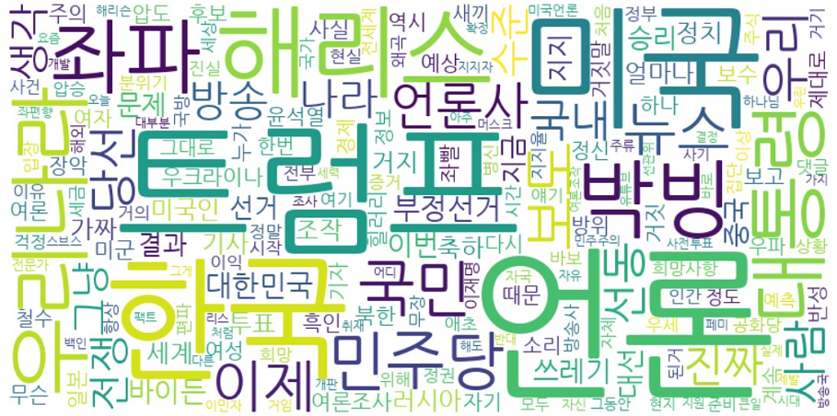

Figure 7. Word Cloud of post-election videos in Korea

The analysis of keyword usage in comments shows that terms related to trade and economic policy—such as "경제" (economy), "관세" (tariff), "세금" (tax), and "무역" (trade)—appeared relatively infrequently, with each accounting for less than 1.3% of total comments. Moreover, these keywords were associated with strongly negative average sentiment scores, particularly "관세" (-0.7950) and "세금" (-0.7805). The low frequency of trade-related terms suggests that Korean commenters were not actively anticipating or discussing trade policy issues prior to the tariff announcement. This supports the interpretation that Korea, having not directly experienced a trade war, was largely unprepared for and surprised by the sudden imposition of tariffs.

### Post tariff videos

In contrast, the post-tariff word cloud exhibited a marked shift toward trade-related terminology. We observed a significant increase in economic terms such as "관세" (tariff), "수출" (exports), and "수입" (imports), reflecting the immediate economic concerns triggered by the policy announcement. Interestingly, mentions of "중국" (China) rose noticeably, indicating increased attention to South Korea's position between its largest trading partner and its key security ally.

The word cloud also revealed the emergence of specific terms absent from the election discourse, including "계란" (eggs) and "탄핵" (impeachment) which reflect the ongoing political and economic issues of that time. This evolution in terminology demonstrated a shift from media criticism to economic and geopolitical concerns, with a more nuanced vocabulary emerging around national identity, sovereignty, and economic impact.

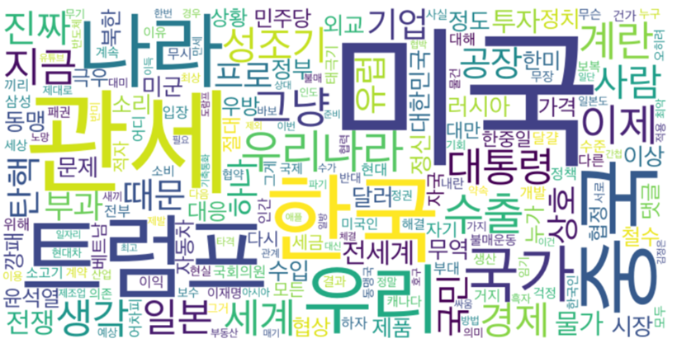

Figure 8. Word Cloud of post-tariff videos in Korea

### Comparison

The comparison between the two word clouds highlighted a fundamental shift in public discourse following the tariff announcement. While election-related comments primarily reflected frustration with domestic media narratives, tariff-related comments showed a more sophisticated engagement with international relations and economic policy. The emergence of trade-specific terminology that was virtually absent in the election period underscores that the tariff announcement represented a significant and unexpected development in Korean public discourse.

## Sentiment analysis of comments in South Korea

### Post-election videos

Following Donald Trump’s re-election on November 6, 2024, public sentiment in South Korea was predominantly negative. Out of the 2,937 YouTube comments analysed from the top five most-viewed election-related videos by major Korean broadcasters, approximately 89.7% reflected negative sentiment, while only 10.3% were classified as positive (4.3% very positive and 6.0% somewhat positive). However, a closer examination of comment content suggests that much of the negativity was not directed at Trump himself but rather at domestic media. Many commenters expressed frustration toward the perceived bias of Korean news organizations, which had strongly suggested that Kamala Harris was likely to win the election. The mismatch between media predictions and the actual result led to a wave of criticism targeting mainstream media, rather than Trump.

텍스트, 스크린샷, 그래프, 라인이(가) 표시된 사진

AI가 생성한 콘텐츠는 부정확할 수 있습니다.

Figure 9. Sentiment score in Trump’s election

In the post-election period, the most prominent keywords in the comments were closely tied to domestic media coverage. Keyword frequency analysis further supports this interpretation. Terms such as “media”, “broadcasting”, and “news” appeared frequently in the dataset, often accompanied by emotionally charged descriptors like “biased,” “trash,” and “manipulative.” This pattern reflects a dominant sentiment of annoyance and distrust toward the media, rather than opposition to Trump’s political platform.

Among the 302 comments classified as positive, a majority celebrated Trump’s return to power. These comments included congratulatory expressions (“Congratulations” – 44 mentions), religious framing (“God” – 18 mentions), and supportive phrases like “Cheer up” (11) and “Support” (9). This suggests that positive commenters viewed Trump’s re-election favourably, framing it as a moment of hope or ideological vindication.

### Post-tariff videos

Following the tariff announcement, the sentiment distribution showed a slight but meaningful shift toward increased negativity. The emotional responses appeared more intense and specific to economic concerns. The proportion of very negative comments increased, while positive sentiment decreased slightly to 7.7%. The nature of negative comments also evolved, with frustration now directed at both the Korean government's lack of preparation and South Korea's limited geopolitical leverage. The emotional tenor of comments suggested a sense of betrayal and disappointment rather than the annoyance that characterized post-election negativity.

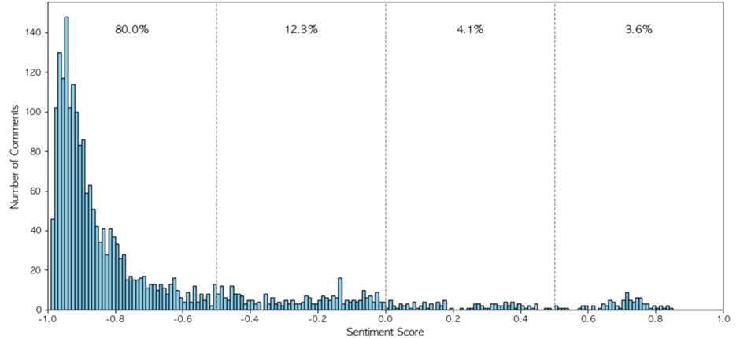

Figure 10. Distribution of sentiment score of post-tariff comments

Our focused analysis of China-related comments revealed interesting patterns. These comments constituted 15% of the total post-tariff dataset, indicating significant attention to the China factor in South Korea's trade dilemma. Their sentiment distribution showed 76.2% very negative, 16.4% somewhat negative, 5.1% somewhat positive, and 2.3% very positive comments. While still predominantly negative, these comments were slightly less negative than the overall post-tariff average. The key theme emerging from China-related comments was criticism of the Korean government for failing to effectively balance relations between the US and China. Many commenters expressed frustration over South Korea's perceived economic dependence on both nations and its vulnerability in the ongoing trade tensions between its two most important international partners.

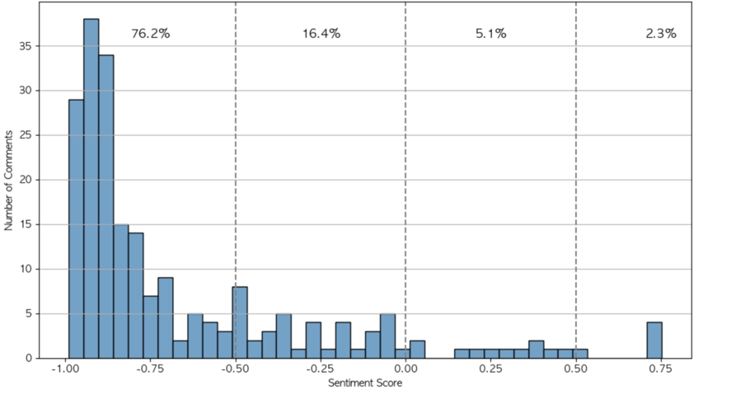

Figure 11. Distribution of sentiment score of post-tariff comments that mention “China”

## K-means analysis

### Post-election videos

Before conducting the clustering analysis, we excluded comments with sentiment scores greater than 0, as these overwhelmingly expressed congratulatory messages regarding President Trump’s re-election. Since these comments showed a consistent tone and did not require further classification, we focused the clustering solely on comments with sentiment scores of 0 or less. The goal was to identify the underlying causes of negative sentiment and explore how users expressed emotional reactions to the election and policy news. Also, we put “Trump” in the stop words list since the topic is about Trump’s election.

The principal component analysis revealed two distinct thematic dimensions in the comments. Principal Component 1 (PC1) is characterized by words such as "media," "Korea," "trash," "left wing," and "fake," suggesting a strong focus on dissatisfaction with domestic media and criticism of left-leaning political perspectives. The component reflects concerns about media manipulation and political bias within Korea.

Principal Component 2 (PC2) is also led by Korea and media-related words, “Press,” but includes a more geopolitically oriented set of terms such as now, “President,” “Democratic party” (Korean political party, not U.S. political party), and “China.” This indicates a focus on international relations, political leadership, and perceived media framing in a global context. Together, the two components highlight overlapping but distinct sources of negative sentiment—media distrust and broader geopolitical anxiety.

Figure 12. presents the results of the clustering analysis. The two clusters show weak separation, indicating that meaningful clustering did not occur. This pattern persisted even when the number of clusters was increased to three or four, indicating that meaningful separation still did not emerge. This outcome appears to be driven by the fact that the dominant theme across all clusters is criticism of the media. The lack of distinct separation was further confirmed through an analysis of the main topics within each cluster, which revealed a consistent focus on media-related dissatisfaction across groups.

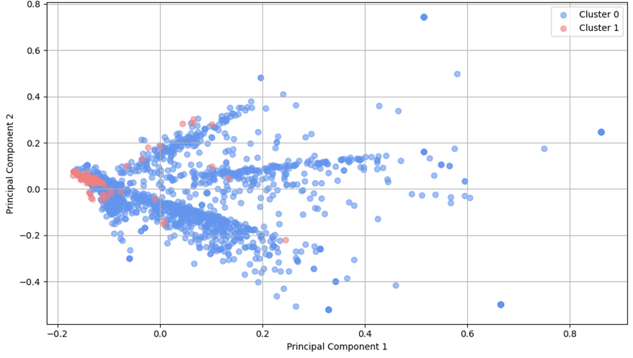

Figure 12. K-means clustering for post-election video

The TF-IDF analysis identified distinct thematic focuses within each cluster. Cluster 0, which contains the majority of comments, is characterized by the frequent use of terms such as Media, Korea, Small difference, Harris, and Left-wing. These keywords indicate a dominant theme of criticism toward the Korean media, especially in relation to political bias and the portrayal of foreign events.

Cluster 1, though much smaller, displays a unique set of terms including “President”, “Press”, “Woman”, “Black”, and “Candidate”. This cluster appears to reflect disappointment with Korean media narratives that emphasized Kamala Harris as a historic candidate, in contrast to the actual outcome of Trump’s re-election. The vocabulary points to a sense of frustration with the gap between media framing and political reality.

### Post-tariff videos

In contrast to the post-election period, the k-means clustering of post-tariff comments revealed two clearly separated groups visible in the PCA visualization. Cluster 0 comprised comments expressing emotional reactions, particularly frustration with Korea's limited geopolitical power and disappointment over investments in the U.S. The keywords associated with this cluster included import, world, and boycott, centred on blame and boycott-related discussions. Cluster 1 represented a more strategic engagement with the issue, focusing on response measures and policy considerations. Its associated keywords included Egg, Trump, and protect, with discussions covering specific affected goods and broader national protection strategies. The clear separation between these clusters in the PCA visualization demonstrated a more complex and structured public discourse following the tariff announcement.

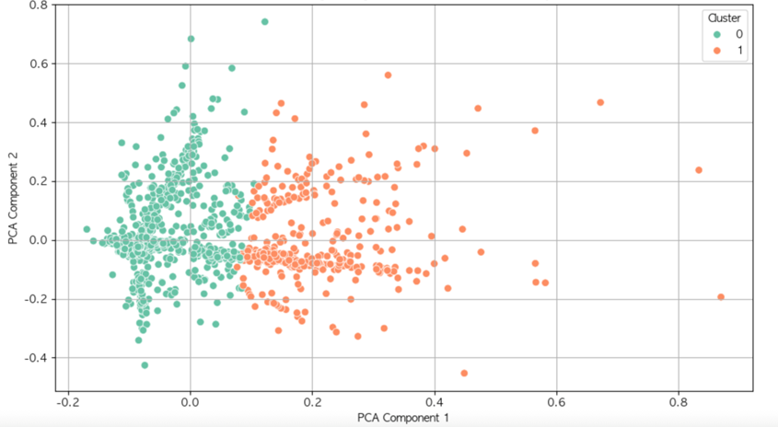

Figure 13. K-means cluster in Trump’s election

### Comparison

The comparison between post-election and post-tariff clustering results revealed a fundamental shift in discourse structure. While post-election comments showed homogeneous content focused almost exclusively on media criticism, post-tariff comments exhibited clear thematic differentiation between emotional responses and strategic discussions. This evolution suggests that the tariff announcement triggered a more sophisticated public debate with distinct response approaches: one emotionally reactive and focused on assigning blame, and another pragmatically oriented toward solution-finding and national interest protection. The emergence of clearly differentiated discourse communities indicates that the tariff issue engaged different facets of public opinion in ways that the election results alone did not.

## Discussions

In the aftermath of Trump’s re-election, public sentiment in South Korea appeared largely negative on the surface, but a closer look revealed that much of the criticism was directed not at Trump himself, but at domestic media outlets. Many users, regardless of whether their comments were classified as positive or negative, expressed political support for Trump while simultaneously voicing frustration with perceived media bias. This suggests that emotional tone alone may not fully reflect political orientation, and that anti-institutional sentiment, particularly toward the press, played a key role in shaping public discourse.

Analysis on the post-tariff videos reveals that the tariff announcement marked a turning point in South Korean public sentiment, shifting from generalized media criticism to deeper concerns about economic vulnerability and geopolitical strategy. Despite a rise in negative reactions, criticism focused more on the Korean government's lack of preparedness than on the U.S. administration. The emergence of China-related discourse underscored growing awareness of Korea's precarious position between global powers. These changes suggest a maturing public discourse—one that, in the face of economic strain, prioritized national strategy over emotional response and held domestic institutions more accountable than foreign actors.

Our analysis discovers significant evolution in South Korean public sentiment between the election and tariff periods. Negative sentiment dominated both periods but stemmed from different sources. The post-election negativity primarily targeted domestic media bias rather than the election outcome itself, while post-tariff negativity reflected disappointment as a US ally and frustration over the Korean government's perceived lack of preparation.

We observed distinct reaction patterns between the two events. Post-election comments showed limited thematic diversity despite high volume. In contrast, post-tariff comments revealed two distinct emotional response groups: one focused on emotional frustration and blame, and the other engaged in strategic discussions about national protection and specific response measures.

An important finding is the anticipation gap revealed by our analysis. The absence of trade-related keywords prior to the tariff announcement suggests South Koreans did not anticipate this policy. This lack of preparation reinforced the shock and emotional volatility observed in post-tariff discourse. The surprise element likely contributed to the slight increase in negative sentiment compared to the election period.

In terms of public discourse implications, our findings suggest South Korean public opinion remained supportive of Trump despite the tariff impact. Criticism was redirected toward domestic media and the Korean government rather than the US administration. The emergence of terms like "eggs," "impeachment," and "Stars and Stripes" indicates a complex narrative developing around national identity and economic sovereignty.

These insights demonstrate how South Korean public sentiment navigated the tension between geopolitical alliance with the US and domestic economic interests during this challenging period of US-Korea relations. The analysis reveals a public more critical of domestic institutions than of international partners, even when those partners implement policies with negative economic consequences for South Korea.

# Conclusions

For China part, after Trump was elected president, the sentiments expressed by Chinese netizens were highly polarized, though overall they leaned slightly positive. This may be attributed to the dramatic nature of Trump’s return to the White House after four years, as well as the excitement of witnessing a historic moment. However, following the announcement of his aggressive tariff plan, the overall sentiment among Chinese netizens became more negative. We also found that users living in provinces with higher export volumes to the U.S. tended to express more negative sentiments. In addition, comments from female users were fewer in number and exhibited more negative sentiment.

Following Trump’s re-election, South Korean public sentiment appeared largely negative, but this was mainly directed at domestic media rather than Trump himself, reflecting deep-seated distrust toward press institutions. In contrast, the tariff announcement triggered a more complex and policy-oriented discourse, with a clear shift toward concerns over economic vulnerability and geopolitical strategy. Public reactions divided into two clusters—one emotional and blame-focused, the other strategic and solution-seeking. Notably, criticism was aimed at the Korean government’s lack of preparedness rather than the U.S. administration. The absence of trade-related terms before the tariff suggests South Koreans were caught off guard, intensifying their response. Overall, the analysis highlights a maturing discourse that, despite rising negativity, prioritized domestic accountability and strategic national interests.